**Neighborhoods Similarity between NYC and Chicago**

Wansu Zhan

11/25/2018

Contents

Introduction 3

Data Description 3

Methodology 4

Neighborhood Exploration 4

Venues Exploration 5

Clustering 6

Results 6

Using All Neighborhoods 6

Using Downtown Neighborhoods Only 7

Discussion 13

Conclusion 13

Appendix 14

## Introduction

Chicago based firms, such as the one I am working for, are constantly hiring talents from all over the country. One common question they are asked by candidates graduated from universities that are based in New York, or are near New York (such as Columbia University, New York University, Cornell University, etc.), is that how Chicago is compared to New York. Those students, who get themselves quite familiar to the New York City and its lifestyle, want to know if they can fit well in Chicago. This project tries to answer such question from the neighborhood similarity perspective. We would like to utilize cluster analysis to help us determine (1) whether there are similarity at all between New York and Chicago neighborhoods (2) If there is, which neighborhoods between New York City and Chicago are similar to each other.

The report may be interesting to people who are considering moving from New York to Chicago, or the other way around. It would also help Chicago and New York based firms answer candidates’ question regarding the similarity between the two cities.

## Data Description

There are mainly two types of data that are used in this project.

1. The neighborhoods and their coordinates of New York City and Chicago.
   * For New York, the data is got from the Week3 Lab of the Coursera Course “Applied data Science Capstone”.
   * For Chicago, we first use python to scrape the neighborhoods of Chicago from Wikipedia “https://en.wikipedia.org/wiki/List_of_neighborhoods_in_Chicago”. Then we got the coordinates of each neighborhood from the combination of below two approaches
     1. Use python to scrape the coordinates of each Chicago neighborhood from the Google Search link. For example, to look up the coordinates of the Neighborhood “Printer’s Row”, whose Community Area is “The Loop”, we would use python to scrape the link <https://www.google.com/search?ei=GTT3W6_kKY_vjwTlg66oDQ&q=Printer%27s+Row+The+Loop+chicago+coordinates>. Generally, we would use the link [https://www.google.com/search?ei=GTT3W6_kKY_vjwTlg66oDQ&q={%s}+{%s} +chicago+coordinates](https://www.google.com/search?ei=GTT3W6_kKY_vjwTlg66oDQ&q=%7b%25s%7d+%7b%25s%7d%20+chicago+coordinates), where the first “%s” would be replaced by the name of the neighborhood, and the second “%s” would be replaced by the name of the Community Area/Borough.
        + Note that we tried to use the package Nominatim of geopy as well, however it fails to get results for a lot of cases. Therefore, we switched to use the google search method.
     2. Manual correction. Most of the results got from above approach are correct. However, there are a few wrong coordinates that need to be manually corrected
   * The total number of distinct neighborhoods we have for New York City is 302, while the total number of distinct neighborhoods we have for Chicago is 119.
2. The venues for each neighborhood. This data is acquired from Foursquare API by using the “explore” functionality.

For preliminary data exploration, please refer to the “Neighborhood Exploration” and “Venues Exploration” of the “Methodology” session below.

## Methodology

### Neighborhood Exploration

We first explore the neighborhood data we have by visualizing graphically for each neighborhood of New York and Chicago as below.

***New York City***

The graph on the left shows the neighborhood/Borough names of New York Manhattan[1], while the graph on the right shows the coordinates of each New York Neighborhood we choose to perform analysis for in this project.

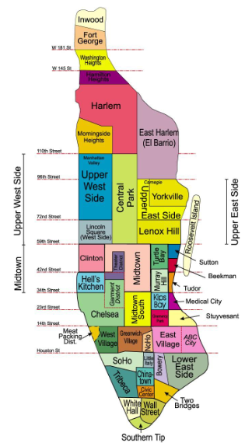 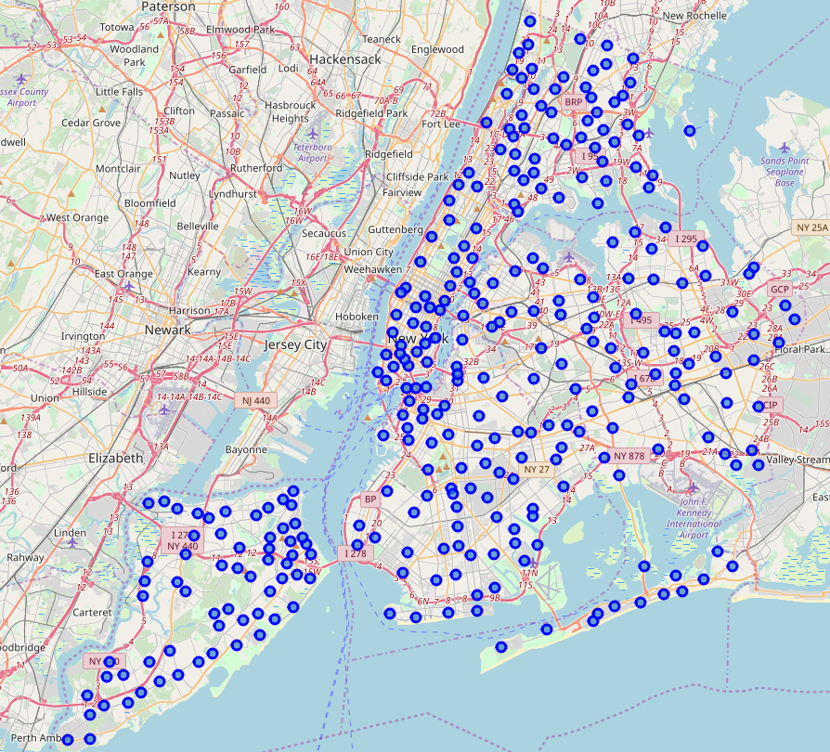

***Chicago***

The graph on the left shows the neighborhood/Borough names of Chicago[2], while the graph on the right shows the coordinates of each Chicago Neighborhood we choose to perform analysis for in this project.

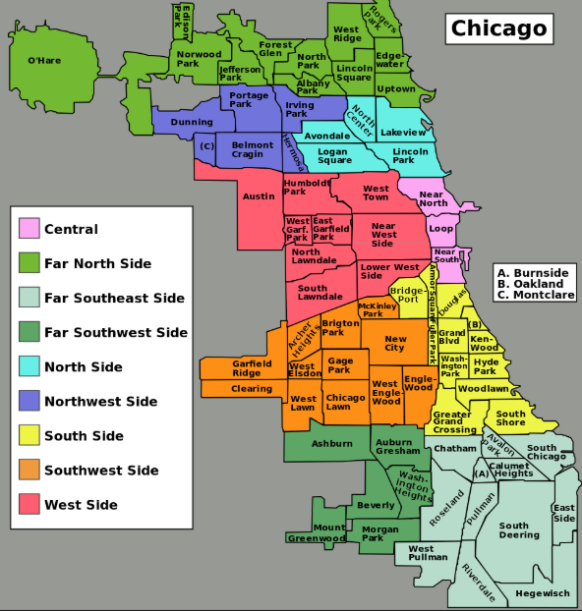 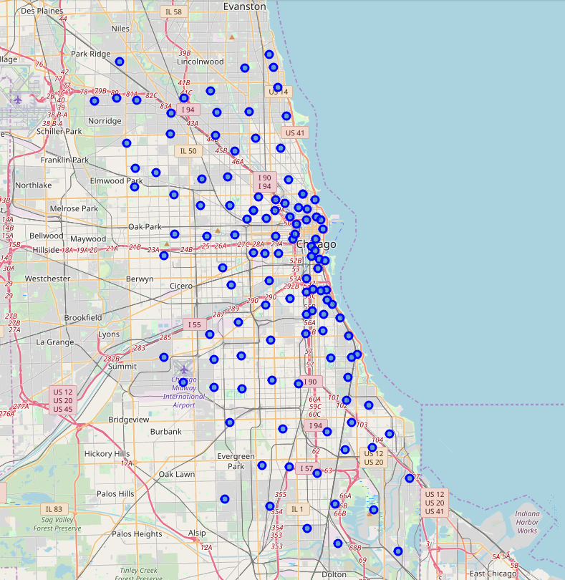

### Venues Exploration

For each neighborhood, we use Foursquare API to get the names and categories of the venues that are within 1km of the neighborhood coordinates. There are 462 and 355 unique venue categories for New York and Chicago respectively and 501 unique venue categories in total for both of them.

At this point, we combined New York and Chicago venues data, and used One-Hot-Encoding for all the venue categories. After this, we got a dataframe with each venue category being a column, and each venue of a neighborhood being a row entry. The value of the dataframe would be either 0 or 1, indicating whether the venue belongs to the venue category within 1km. We then aggregate the dataframe by Neighborhood, and calculate the mean of the Venue Categories, so that we get the portion of each venue category for each neighborhood. This will prepare us for performing clustering later.

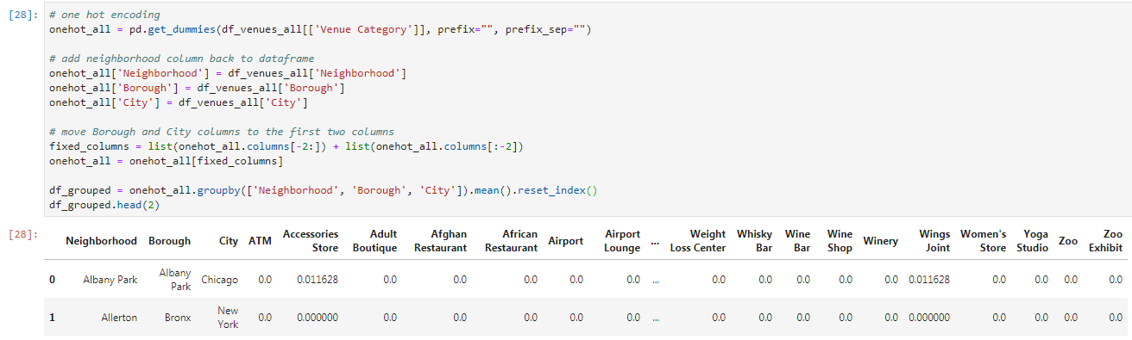

In addition, we also get the top 10 common venue categories for each neighborhood for further cluster results examination. The data looks like below

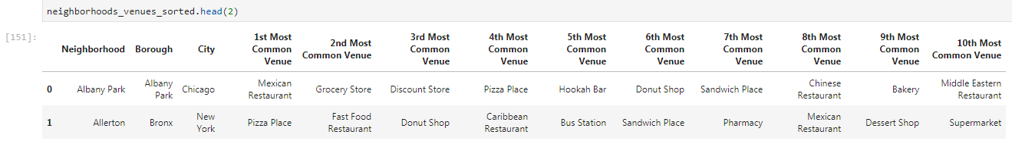

### Clustering

Cluster analysis or clustering is the task of grouping a set of objects in such a way that objects in the same group (called a cluster) are more similar (in some sense) to each other than to those in other groups (clusters). It is a main task of exploratory data mining, and a common technique for statistical data analysis, used in many fields, including machine learning, pattern recognition, image analysis, information retrieval, bioinformatics, data compression, and computer graphics[3]. Clustering is suitable for our problem here, as it can help us to understand the similarity between neighborhoods by determining which neighborhoods belong to the same clusters.

One of the simplest models among clustering approaches is K means. In this project, we will use K means to perform cluster analysis. The feature we choose to use is the portion of each venue category for each neighborhood, as calculated in previous section.

We will first perform cluster analysis for all neighborhoods of New York and Chicago. Then we will perform cluster analysis for only the downtown area of New York and Chicago. Here for New York, a neighborhood belongs to “downtown” if its borough is Manhattan; while for Chicago, a neighborhood belongs to “downtown” if its borough is The Loop, Near North Side, Near South Side, or Near West Side[4].

## Results

### Using All Neighborhoods

Using 5 clusters, below graphs show the clustering results for all neighborhoods of New York and Chicago neighborhoods, with each color representing a different cluster. New York is on the left while Chicago is on the right.

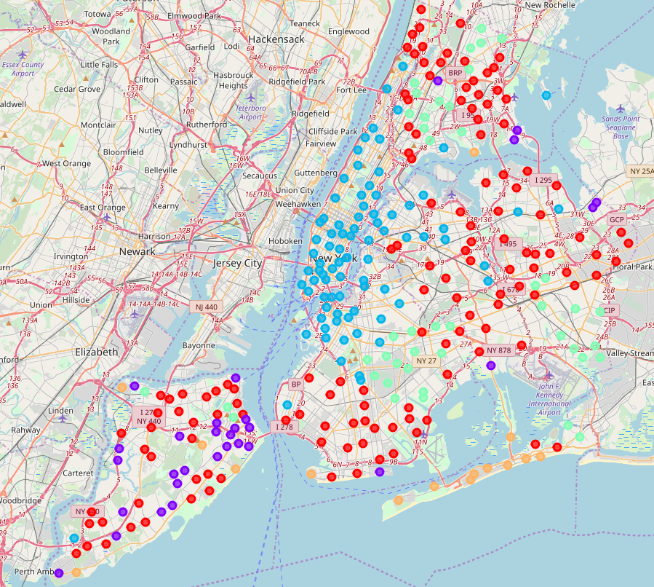 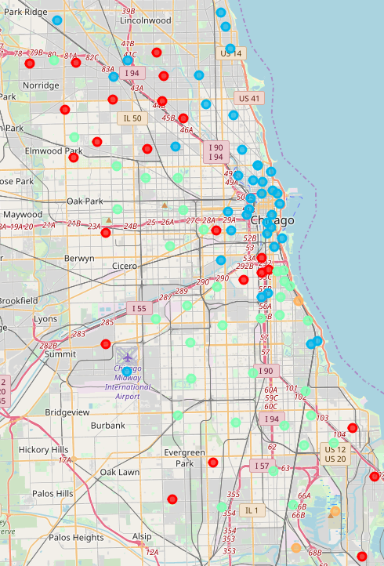

As shown from the graph, we see that there are indeed similarities between New York and Chicago neighborhoods, from the perspective of nearby venues. For example, as one might have guessed, Manhattan area is very similar to Chicago downtown area, as indicated by blue dots in the graphs. In addition, some New York neighborhoods in Bronx, Staten Island, Brooklyn and Queens are similar to neighborhoods in Chicago suburbs in the south and west, indicating by red dots and green dots. We also found that some neighborhoods in Staten Island at New York is not similar to any Chicago neighborhoods, as indicated by purple dots. Please see Appendix for more information of the cluster results. We also vary the number of clusters used, and the main results will not change much.

### Using Downtown Neighborhoods Only

We then performed a similar but more detailed analysis to only downtown area for both cities, with the attempt to further classify these areas. Note that there are 40 New York neighborhoods and 22 Chicago neighborhoods belong to the downtown area we defined.

The clustered results using 5 clusters are as below, with New York on the left and Chicago on the right.

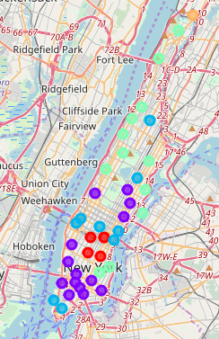 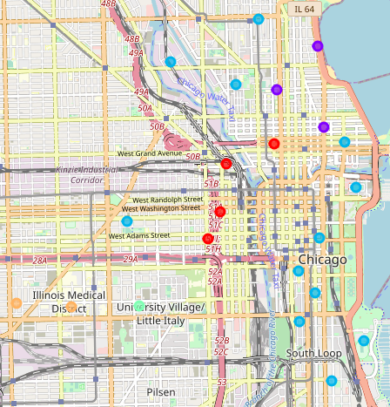

Below table summarizes the proportion of clusters that each Borough belong to for New York/Chicago downtown area, with color of each cluster corresponding to the color shown in the map.

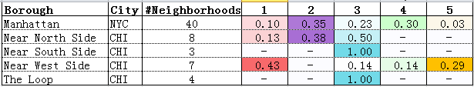

Now let’s examine each cluster further.

#### Cluster1 (red dots)

There are 8 neighborhoods in total belong to this cluster, as listed below.

* New York
  + Flatiron, Gramercy, Midtown South, Murray Hill
* Chicago
  + Fulton River District, Greektown, River North, West Loop

Below table shows the top 10 common venues for neighborhoods that belong to this cluster:

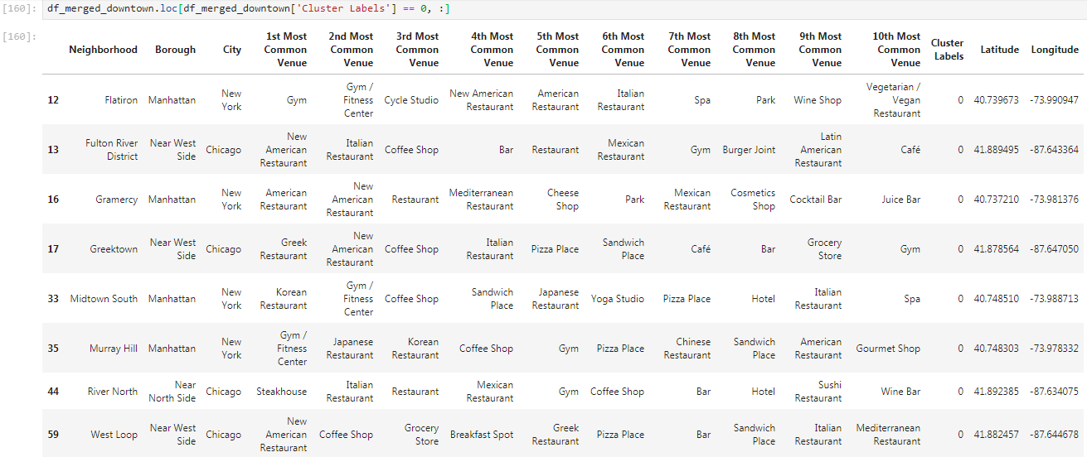

The venues that appear in the top 10 categories by frequency for this cluster are displayed as below, where venues like Italian Restaurant, Coffee Shop, New American Resaurant, Gym etc. show up.

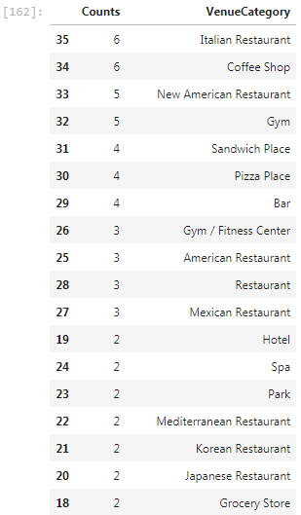

#### Cluster2 (purple dots)

One can see from the graph that New York neighborhoods in lower Manhattan, such as Soho and Little Italy, as well as some neighborhoods in the middle of Manhattan, such as Lincoln Square and Upper East Side, are similar to Chicago neighborhoods in the near north, such as Magnificent Mile and Gold Coast, and they all belong to this purple cluster.

Below table shows the top 10 common venues for neighborhoods that belong to this cluster:

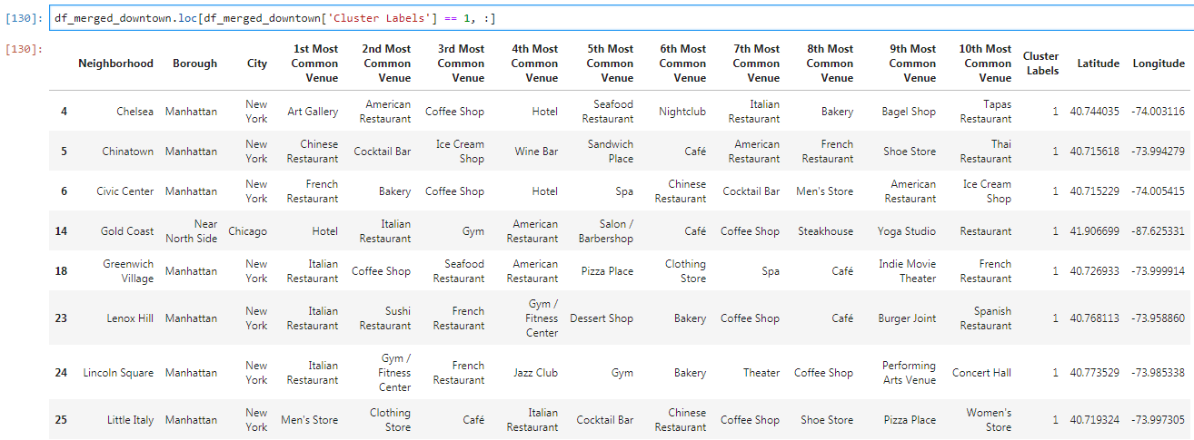

The venues that appear in the top 10 categories by frequency for this cluster are displayed as below, where venues like Italian Restaurant, Coffee Shop, American Resaurant, as well as Hotel, Gym, Men’s Store etc. show up.

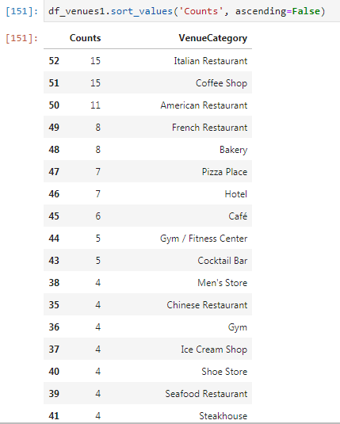

Full list of the 17 neighborhoods belong to this cluster are as below:

* New York
  + Chelsea, Chinatown, Civic Center, Greenwich Village, Lenox Hill, Lincoln Square, Little Italy, Lower East Side, Noho, Soho, Sutton Place, Tribeca, Upper East Side, West Village
* Chicago
  + Gold Coast, Magnificent Mile, Near North Side

#### Cluster3 (blue dots)

There are 21 neighborhoods in total belong to this cluster, as listed below.

* New York
  + Battery Park City, Carnegie Hill, Central Harlem, Clinton, Financial District, Hudson Yards, Midtown, Tudor City, Turtle Bay
* Chicago
  + Cabrini-Green, Dearborn Park, Goose Island, Museum Campus, Near East Side, Near West Side, Old Town, Prairie Avenue Historic District, Printer's Row, South Loop, Streeterville, The Loop

Note that all neighborhoods of the two Chicago Boroughs, “Near South Side” and “The Loop”, belong to this cluster.

Below table shows the top 10 common venues for neighborhoods that belong to this cluster:

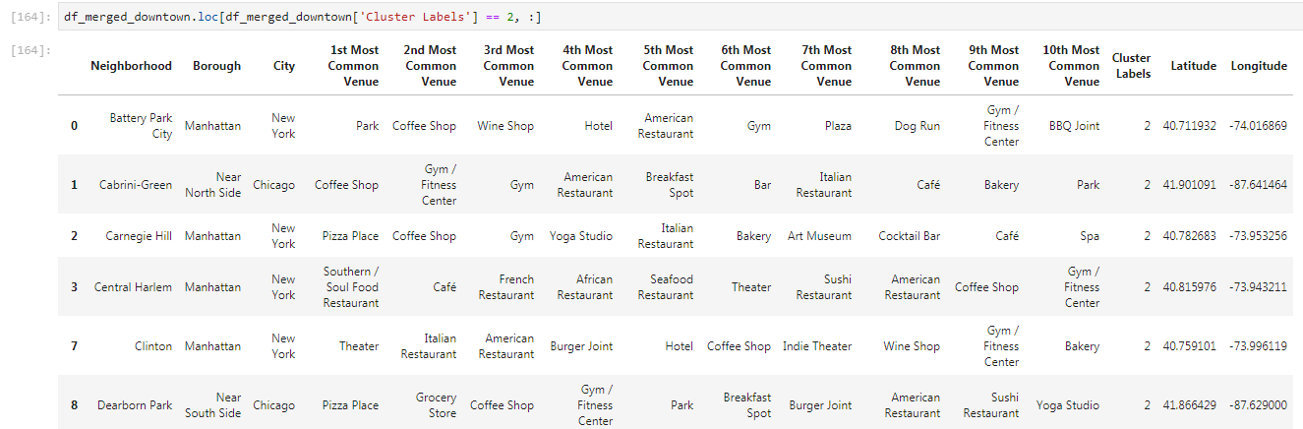

The venues that appear in the top 10 categories by frequency for this cluster are displayed as below, where venues like Coffee Shop, American Resaurant, Hotel, Pizza Place, Park etc. show up.

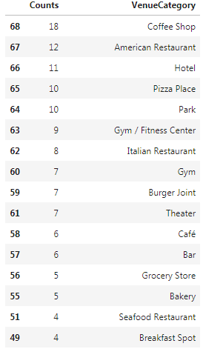

#### Cluster4 (green dots)

There are 13 neighborhoods in total belong to this cluster, as listed below.

* New York
  + East Harlem, East Village, Hamilton Heights, Inwood, Manhattan Valley, Manhattanville, Morningside Heights, Roosevelt Island, Stuyvesant Town, Upper West Side, Washington Heights, Yorkville
* Chicago
  + Little Italy/University Village

Below table shows the top 10 common venues for neighborhoods that belong to this cluster:

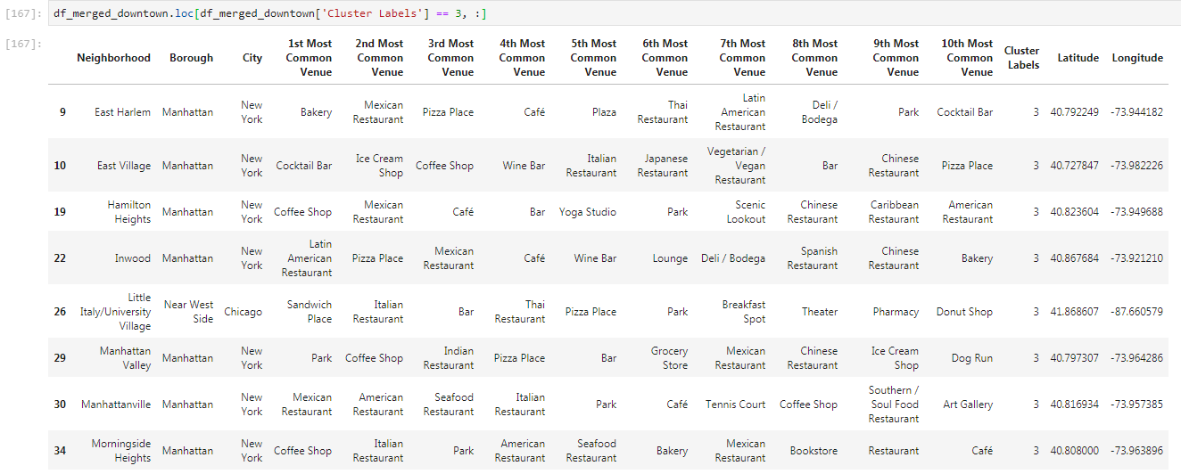

The venues that appear in the top 10 categories by frequency for this cluster are displayed as below, where venues like Park, Pizza Place, Mexican Restaurant, Coffee Shop, Bar etc. show up.

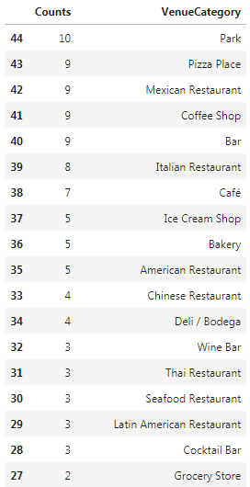

#### Cluster5 (orange dots)

There are only 3 neighborhoods in total belong to this cluster, as listed below.

* New York
  + Marble Hill
* Chicago
  + Illinois Medical District, Tri-Taylor

Below table shows the top 10 common venues for neighborhoods that belong to this cluster:

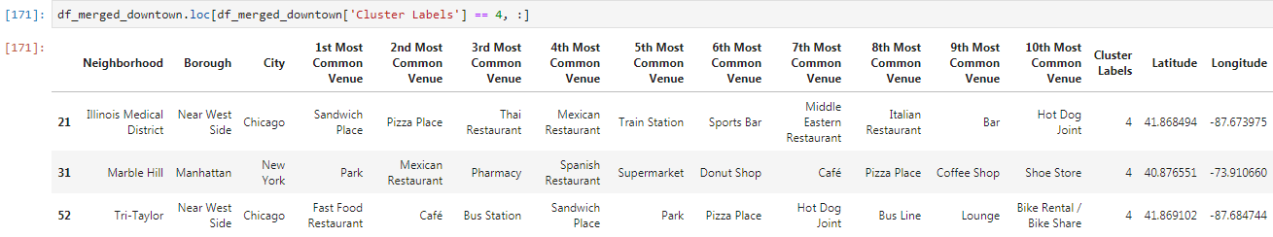

The venues that appear in the top 10 categories by frequency for this cluster are displayed as below, where venues like Pizza Place, Sandwich Place, Park etc. show up.

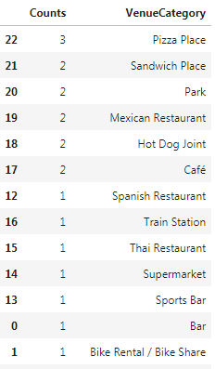

## Discussion

From the clustering results, we can see that when using all neighborhoods data, we see that Manhattan area is very similar to Chicago downtown area. In addition, some New York neighborhoods in Bronx, Staten Island, Brooklyn and Queens are similar to neighborhoods in Chicago suburbs in the south and west. That being said, some New York neighborhoods, such as those in Staten Island, are not similar to any Chicago neighborhoods.

When using only downtown area data, we further understand the similarity between New York and Chicago neighborhoods. For example, New York neighborhoods in lower Manhattan, such as Soho and Little Italy, as well as some neighborhoods in the middle of Manhattan, such as Lincoln Square and Upper East Side, are similar to Chicago neighborhoods in the near north, such as Magnificent Mile and Gold Coast.

Note that the similarity in this analysis is all based on the proportion of nearby venues categories. If one has more time, we can further investigate the similarity between neighborhoods of the two cities from different angles. Using similar venue dataset, we can explore similarity using convenience score, or focusing on specific venues, like restaurants. Using different dataset, we can explore similarity of neighborhoods from other perspectives, such as weather, relative house prices, lifestyle of people, etc.

## Conclusion

In this paper, we use K means to perform cluster analysis to help us understand the similarity of neighborhoods of New York and Chicago. The data shows that there are indeed similarities among neighborhoods of these two cities. When using all neighborhoods data, one can see that Manhattan is very similar to Chicago downtown area. In addition, some New York neighborhoods in Bronx, Staten Island, Brooklyn and Queens are similar to neighborhoods in Chicago suburbs in the south and west. That being said, some New York neighborhoods, such as those in Staten Island, are not similar to any Chicago neighborhoods.

When using only downtown area data, we further identified the similarity between New York and Chicago neighborhoods. For example, New York neighborhoods in lower Manhattan, such as Soho and Little Italy, as well as some neighborhoods in the middle of Manhattan, such as Lincoln Square and Upper East Side, are similar to Chicago neighborhoods in the near north, such as Magnificent Mile and Gold Coast.

The paper should help interested readers to understand the neighborhood similarity between New York and Chicago from nearby venue categories perspective. Given more time, one can further explore the similarities from different perspectives, as mentioned in the Discussion section above.

## Appendix

Below table shows the proportion of cluster each Borough of New York and Chicago belongs to. There are 70 boroughs in total for both cities. The columns 1 to 5 below represent the 5 clusters, and the colors correspond to the colors used in the map.

|  |  |  |  |  |  |  |  |
| --- | --- | --- | --- | --- | --- | --- | --- |
| **Borough** | **City** | **#Neighborhoods** | **1** | **2** | **3** | **4** | **5** |
| Albany Park | CHI | 1 | 1.00 | - | - | - | - |
| Archer Heights | CHI | 1 | - | - | - | 1.00 | - |
| Armour Square | CHI | 3 | 0.67 | - | 0.33 | - | - |
| Ashburn | CHI | 1 | - | - | - | 1.00 | - |
| Auburn Gresham | CHI | 1 | - | - | - | 1.00 | - |
| Austin | CHI | 4 | 0.50 | - | - | 0.50 | - |
| Austin, Humboldt Park | CHI | 1 | - | - | - | 1.00 | - |
| Avalon Park | CHI | 1 | - | - | - | 1.00 | - |
| Avondale | CHI | 1 | 1.00 | - | - | - | - |
| Belmont Cragin | CHI | 1 | 1.00 | - | - | - | - |
| Beverly | CHI | 1 | 1.00 | - | - | - | - |
| Bridgeport | CHI | 1 | 1.00 | - | - | - | - |
| Brighton Park | CHI | 1 | - | - | - | 1.00 | - |
| Bronx | NYC | 52 | 0.60 | 0.06 | 0.06 | 0.27 | 0.02 |
| Brooklyn | NYC | 69 | 0.39 | 0.01 | 0.36 | 0.22 | 0.01 |
| Burnside | CHI | 1 | - | - | - | 1.00 | - |
| Calumet Heights | CHI | 1 | - | - | - | 1.00 | - |
| Chatham | CHI | 1 | - | - | - | 1.00 | - |
| Chicago Lawn | CHI | 1 | - | - | - | 1.00 | - |
| Clearing | CHI | 1 | - | - | 1.00 | - | - |
| Douglas | CHI | 7 | 0.14 | - | 0.14 | 0.71 | - |
| Dunning | CHI | 1 | 1.00 | - | - | - | - |
| East Garfield Park | CHI | 1 | - | - | - | 1.00 | - |
| East Side | CHI | 1 | 1.00 | - | - | - | - |
| Edgewater | CHI | 1 | - | - | 1.00 | - | - |
| Edison Park | CHI | 1 | - | - | 1.00 | - | - |
| Englewood | CHI | 1 | - | - | - | 1.00 | - |
| Forest Glen | CHI | 1 | - | - | 1.00 | - | - |
| Fuller Park | CHI | 1 | - | - | - | 1.00 | - |
| Gage Park | CHI | 1 | - | - | - | 1.00 | - |
| Garfield Ridge | CHI | 1 | 1.00 | - | - | - | - |
| Grand Boulevard | CHI | 1 | - | - | - | 1.00 | - |
| Greater Grand Crossing | CHI | 1 | - | - | - | 1.00 | - |
| Hegewisch | CHI | 1 | 1.00 | - | - | - | - |
| Hermosa | CHI | 1 | 1.00 | - | - | - | - |
| Humboldt Park | CHI | 1 | - | - | - | 1.00 | - |
| Hyde Park | CHI | 2 | - | - | 1.00 | - | - |
| Irving Park | CHI | 1 | 1.00 | - | - | - | - |
| Jefferson Park | CHI | 1 | - | - | 1.00 | - | - |
| Kenwood | CHI | 1 | - | - | - | 1.00 | - |
| Lake View | CHI | 1 | - | - | 1.00 | - | - |
| Lincoln Park | CHI | 2 | - | - | 1.00 | - | - |
| Lincoln Square | CHI | 1 | - | - | 1.00 | - | - |
| Logan Square | CHI | 1 | - | - | 1.00 | - | - |
| Lower West Side | CHI | 1 | - | - | 1.00 | - | - |
| Manhattan | NYC | 40 | 0.03 | - | 0.98 | - | - |
| McKinley Park | CHI | 1 | - | - | - | 1.00 | - |
| Montclare | CHI | 1 | - | - | - | 1.00 | - |
| Morgan Park | CHI | 1 | - | - | - | 1.00 | - |
| Mount Greenwood | CHI | 1 | 1.00 | - | - | - | - |
| Near North Side | CHI | 8 | - | - | 1.00 | - | - |
| Near South Side | CHI | 3 | - | - | 1.00 | - | - |
| Near West Side | CHI | 7 | 0.14 | - | 0.71 | 0.14 | - |
| New City | CHI | 1 | - | - | - | 1.00 | - |
| North Center | CHI | 1 | - | - | 1.00 | - | - |
| North Lawndale | CHI | 1 | - | - | - | 1.00 | - |
| North Park | CHI | 1 | 1.00 | - | - | - | - |
| Norwood Park | CHI | 2 | 0.50 | - | - | 0.50 | - |
| O'Hare | CHI | 1 | 1.00 | - | - | - | - |
| Oakland | CHI | 1 | - | - | - | - | 1.00 |
| Portage Park | CHI | 1 | 1.00 | - | - | - | - |
| Pullman | CHI | 1 | - | - | - | 1.00 | - |
| Queens | NYC | 81 | 0.53 | 0.04 | 0.17 | 0.15 | 0.11 |
| Riverdale | CHI | 1 | - | - | - | - | 1.00 |
| Rogers Park | CHI | 2 | - | - | 1.00 | - | - |
| Roseland | CHI | 1 | - | - | - | 1.00 | - |
| South Chicago | CHI | 1 | 1.00 | - | - | - | - |
| South Deering | CHI | 1 | - | - | - | - | 1.00 |
| Staten Island | NYC | 63 | 0.51 | 0.37 | 0.02 | 0.05 | 0.06 |
| The Loop | CHI | 4 | - | - | 1.00 | - | - |

1. See <https://www.pinterest.com/pin/302233824963969541/>
2. See <https://sk.wikipedia.org/wiki/S%C3%BAbor:Chicago_community_areas_map.svg>
3. See <https://en.wikipedia.org/wiki/Cluster_analysis>
4. The east side of Chicago Loop is the Michigan Lake ☺